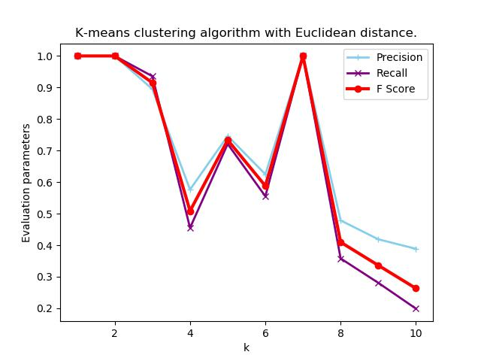

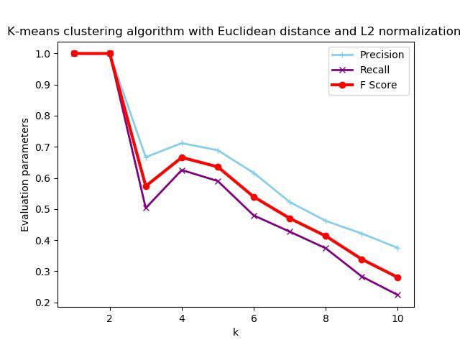

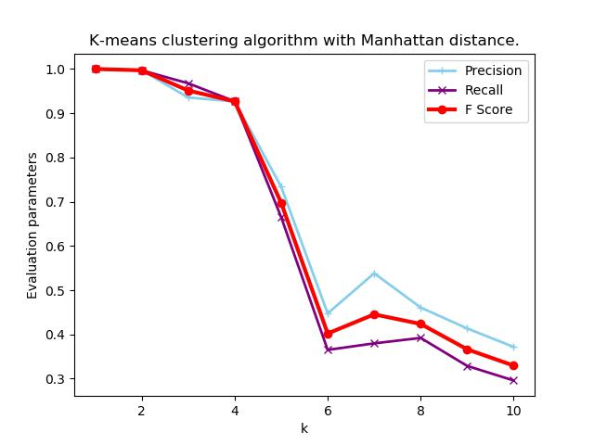

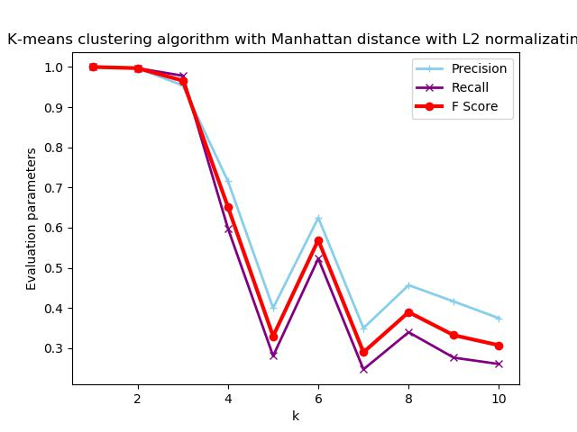

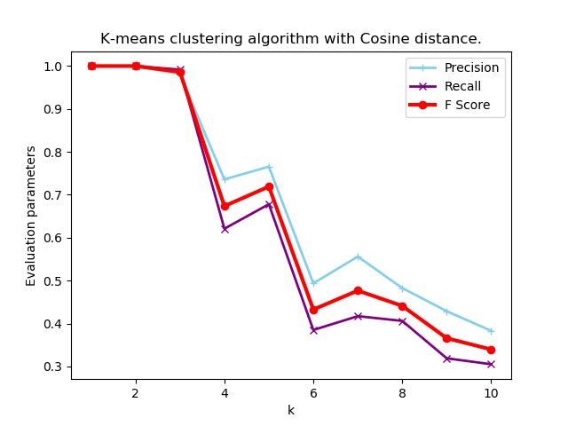

**Summary**

The data what we have been provided with contains 4 different categories. Because of this, the value of K is 4. This will help us determine what the best algorithm is.

From the various graphs above, the graph which is titled “K-means clustering algorithm with Manhattan distance” shows the highest values of F Score, precision and recall when K is 4.

From this, I summarise that the K-means clustering algorithm with Manhattan distance and no normalization of data is the best suited method for maximum results.